EDUC 641 Lab: Applied Statistics in Education and Human Services I
Lab 3: 10/16 and 10/17
Installing packages, exploring tidyverse/ggplot2, and creating visualizations using geom_bar()
Goals:
- Installing and loading packages
- Using ggplot() to describe one categorical variable
- Using ggplot() to describe two categorical variable
Packages background
Tidyverse is a collection of R packages designed to make data manipulation and analysis more efficient, consistent, and user-friendly. It's not a single package but a suite of packages that work together cohesively.
- ggplot2: is one of the packages of the "tidyverse" ecosystem in R, which provides a consistent and efficient way to work with data and create visualizations.
- dplyr: Used for data manipulation, including filtering, summarizing, and arranging data.
- tidyr: Designed for tidying and reshaping data, such as converting data from wide to long format.
- readr: A package for efficient reading and writing of data from various file formats.
- purrr: Provides tools for working with functions and vectors.
- tibble: A modern data frame package with improved features over the default R data frames.
- stringr: Offers functions for working with strings and text data.
- forcats: Useful for working with categorical data and factors.

Today’s Lab
- Installing and loading packages:
- Install package using “ quotes around package name ” - do this only once.
install.packages(“package_name”) # or delete this line of code after it has been run
- Load your package using ` library() ` - run this every time you need to use a specific package. Ex. `library(tidyverse) ` or ` library(here) `.
# install.packages(“tidyverse”)
library(tidyverse)
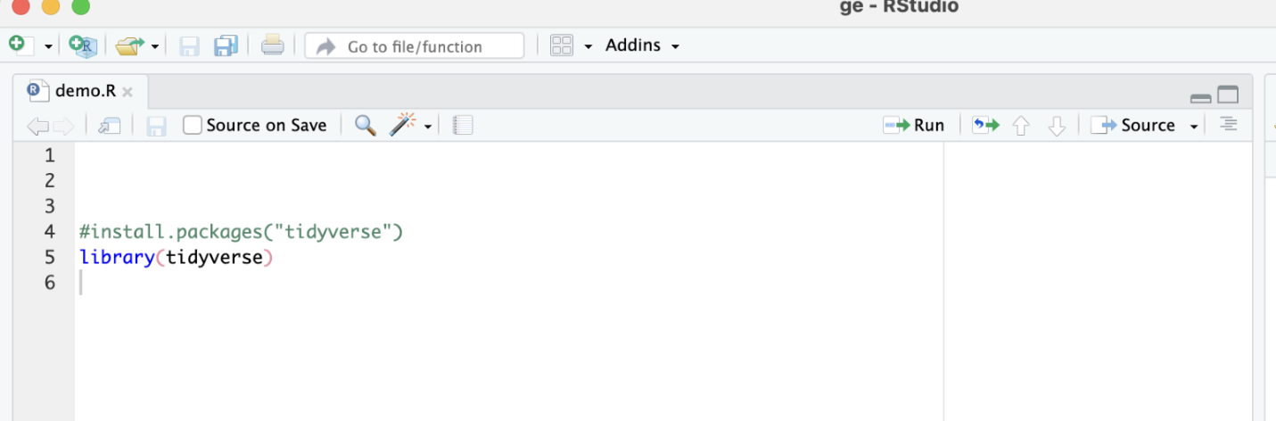
Try yourself: Install and load the package “modelsummary.” We will use this later in the term.

- Describe one categorical variable from the cat.csv dataset
- Select one categorical variable from your dataset and use a bar chart to visualize the counts of each category.
ggplot(name_of_data, aes(x = name_of_categorical_variable)) +
geom_bar()+
labs(
x = "Give a descriptive x-axis label",
y = "Give a descriptive y-axis label",
title = "Give a descriptive title"
) +
theme_minimal() # theme_minimal() is a function that improves your visualization of your graph

Try yourself: with another categorical variable.

- Describe two categorical variables from the cat.csv dataset
- Let's say you have a dataset with two categorical variables, "Category" and "Group," and you want to create a grouped bar chart to visualize the counts of each category within each group. You can do this as follows:
ggplot(name_of_data, aes(x = name_of_categorical_variable, fill = name_of_group)) +
geom_bar(position = “dodge”) + # When you set position = "dodge", bars are positioned side by side
labs(
x = "Give a descriptive x-axis label",
y = "Give a descriptive y-axis label",
title = "Give a descriptive title"
) +
theme_minimal() # theme_minimal() is a function that improves your visualization of your graph
NO (position = “dodge”) example
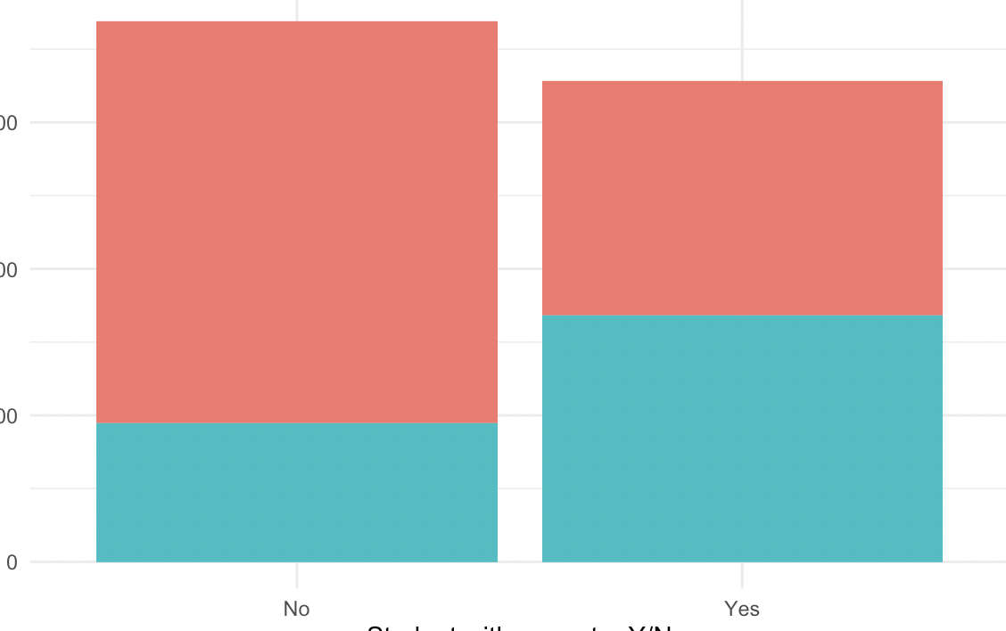
YES (position= “dodge”)
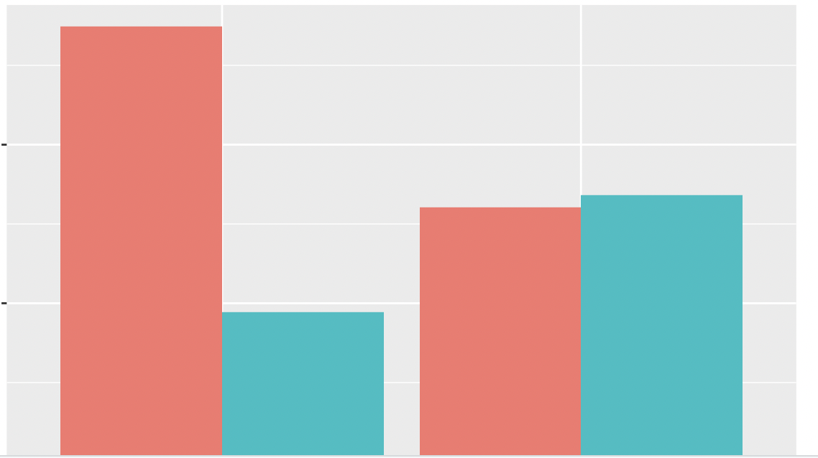
Note. Plots with bars plotted side by side are more readily interpretable to the viewer and are the preferred visualization.

Reminder: To export, use the following code. The files will be saved in the path you specify.

write.csv(counts, "tables/counts.csv")
ggsave(filename = "figures/barplot.jpeg") #uses default width and height, which can be changed. This
must come right after the plot you want to save

